Quality Assurance for CanBeWell 2.0

Project Report for DTI 6997, Summer 2021
Submitted to Prof. Liam Peyton
Prepared by Juveriya Zameer (300116986)


UNIVERSITY OF OTTAWA
Ottawa, Ontario, Canada

Abstract

CanBeWell (https://canbewell-uottawa.firebaseapp.com/) is a multi-platform healthcare APP leading by Dr. CléoMavriplis to provide a reliable and up-to-date source of healthcare information for both patients and providers in Canada. The project aims to provide quality assurance testing of the Canbewell application manually and automatically. Cypress is used to run automatic test Script. Furthermore, there is a comparative study between automatic testing tool like Selenium and Cypress.
This project initiated with the need of testing a web application, Canbewell 1.0. Initially rigorous manual testing was done for Canbewell 1.0 which helped me to realize the importance of automation testing following agile methodology as the application is in the developing phase. As the Canbewell 2.0 team needed a web-project-based automated testing option. The group wished to use a web application's GUI testing software to conduct their tests. This test environment should be created to run test cases with greater reliability and speed. Moreover; the web application is React based, hence I preferred to use a tool that supports JavaScript for future testing work. Additionally, it was necessary to test the entire system following each new implementation. The testing had to be even simpler. The group was concerned about how the application performed with regards to the users. Therefore, Cypress was used to create the testing environment.
Keywords: Cypress, healthcare 3.0, Automation testing, Manual testing.

Acknowledgement

My journey with CanBeWell began in Summer 2020. I was working with Professor Liam Peyton as a COOP student. I was introduced to quality assurance testing for the first time and I had a wonderful learning experience with a diligent team.
I am grateful for the opportunity to work in amazing team of CanBeWell. Particularly, I want to express the deepest gratitude to Prof. Liam Peyton, for being my supervisor and mentoring me through the project. Besides, he provided me with freedom, support, and flexibility to explore on my interests while I was completing this project.Also, I am grateful forDr. CléoMavripliswho showed great patience to students and all team mates worked on CanBeWell.
Last but not the least, I want to thank my family especially my husband and friends for their support during these uncertain times.

Contents
List of Figures 5
1. Introduction 6
1.1 Problem Statement 7
1.2 Motivation 8
1.3 Deliverable 8
2 Background 9
2.1 Healthcare 3.0: CanBeWell 9
2.2 Software Quality Assurance 10
2.3 Cypress 11
2.4 Slack, Trello and GitHub 12
2.4.1 Slack 12
2.4.2 Trello 14
2.4.3 GitHub 16
2.4.4 Visual Studio 17
3 Manual Testing: CanBeWell 18
3.1 Creating Test Plan 18
3.2 Test Results by various Devices and Browsers 27
3.3 Log defects in GitHub 31
3.4 Regression Testing 31
4 Automation Testing for CanBeWell 2.0 32
4.1 Creating Test Plan for Functionality testing 32
4.2 Set-up automation testing environment: Installing Cypress 35
4.3 Test Scripts Code 40
4.4 Test Results 42
5 Comparative study on Cypress and Selenium as Functional testing tool: 43
5.1 Test Efficiency 44
5.2 Requirement-based test coverage 44
5.3 Graphical user interface testing 44
5.4 Cost 45
5.5 Ease of Use 45
6 Conclusion: 45
7 Future work: 45
8 References 46

List of Figures

Figure 1. Automation testing channel on Slack 13
Figure 2 Trello board for Canbewell 1.0 14
Figure 3. Trello board for Transgender/ 15
Figure 4. GitHub repository for Canbewell 16
Figure 5. Visual studio code editor 17
Figure 6. Canbewell 1.0 test plan 19
Figure 7. Canbewell Test Plan: URL testing 23
Figure 8. Content sheet for topic and Test tab in the application 26
Figure 9. Content Testing in iPhone with Safari browser 29
Figure 10. Logging Issues in Github 31
Figure 11. New Changes of covid 19 icon updated and tested 32
Figure 12. Code snippets from can_be_well.js file in Visual studio code editor 41
Figure 13. Executing test script in Cypress Test Runner 42
Figure 14. Test Results in test runner 43

Introduction

It’s surreal to think about how drastically the world has changed in such a short amount of time, and Canada’s health-care system is no exception. Healthcare digitization has been in a trend for recent years. It is interesting and critical for us to view technology in healthcare from different aspects, and consider what kind of role it plays, what methodologies are adopted, what theory supports it, and what contribution it provides for healthcare. As we know, digitization has already been adopted in many sectors of healthcare system, such as hospital record system, medical image processing, and diagnostics.
Those research projects aim to reduce the cost or improve efficiency for the hospitals and physicians. However, after the global pandemic of 2019, since social distancing was suggested for combating the spread of COVID, patients around the world had to browse healthcare and medical information, book appointments, or even receive remote diagnosis over the computer. Therefore, we must figure out how to improve the quality of healthcare information online, and how to get insights of patients when the communication between patients and physicians is not in a face-to-face mode.
Digital health tools like healthcare apps are great for identifying symptoms of new illnesses or the worsening of existing conditions. Digital healthcare apps and products manage chronic problems to eliminate provider costs and reduce the number of emergency room visits, doctor appointments, and hospital admissions that patients need.Applications like Canbewell plays a crucial role to control medical conditions that can largely be controlled through suitable lifestyle measures providing correct information online. That’s where healthcare apps and wearables come into the picture – by offering a way for patients to control their health like never.

Problem Statement

Dr.CléoMavriplis, who bases in Ottawa as a physician and family doctor, initialized a healthcare project named “Update on Age-appropriate Preventative Measures and Screening for Canadian Primary Care Providers”, with Dr. Tawnya Shimizu and Dr. Manon Bouchard in 2016. They found that although healthcare information was easy to acquire online, it is hard for Canadians to find whether the information is reliable and whether the health recommendations were suitable for their age and gender. Therefore, they aimed to provider a reliable and practical source of healthcare information based on their review of Canadian healthcare recommendations and statements from the Canadian Task Force on Preventative Healthcare and other supportive researches.
In order to achieve their goal, they have been collaborating with Prof. Liam Peyton’s research group in the University of Ottawa to build a mobile cross-platform healthcare application to provide access of reliable information to both patients and physicians. So far, the research project and mobile application has been named “CANBeWell” and hosted in Firebase (https://canbewell-uottawa.firebaseapp.com/). In general, the APP does not require registration in order to protect users’ privacy, and it will ask for whether a user is a patient or a physician, the concerned age, and concerned gender before showing medical recommendations.
The application is advancing every week as new developments required by Dr Cleo are implemented in the by our development team. When the application was in the first face which is CanBeWell, a lot of manual testing is required which is quite labour intensive and cumbersome to the developer as each member must participate to compensate the load of testing work.This project aims to automate the testing of the CanBeWell web application.

Motivation
CanBeWell is an on-going project with various teams working onits development. When the web application was in its first release, it required rigorous manual testing. In order to complete the testing of the web application each member from different teams participated. Even the members in the development team also participated in the testing to ensure that the testing will be completed before the release date.However;more and more people are required for testing which resulted in the hiring of new cohorts in the team.

The STLC includes requirement analysis, test planning, test case development, test environment setup, test execution and test cycle closure.In one test cycle the amount of work is overwhelming. I was also working with the CanBeWell then,and the overall experience with manual testing was time consuming, expensive and labour intensive.

When our team started planning on development of CanBeWell 2.0, based on ourprevious experience with manual testing, I proposed the idea to automate the testing of the web-application. This will save cost of labour and amount of time require for testing. Since the web is built in JavaScript,it would be an appropriate choice of using Cypress as automation tool.

Deliverable
This section lists the deliverable of this project.
- Create a Test Plan with test cases and test steps for functionality testing in Excel.
- Test the web application manually and record bugs before automation testing
- Set up testing environment for Cypress.
- Writing test scripts for functionality testing.
- Executing the test scripts and record the process for future work.

Background
The healthcare is evolving continuously, it began from doctors and process focussed Healthcare 1.0 to technology centric Healthcare 2.0. Now, it is a blend of technology and human with mHealth applications. Mobile healthcare applications play a crucial role in the patient education, disease self-management, and remote monitoring of patients.”Many medical applications for smartphones have been developed and widely used by health professionals and patients. The use of smartphones is getting more attention in healthcare day by day. Medical applications make smartphones useful tools in the practice of evidence-based medicine at the point of care,[1]”

Healthcare 3.0: CanBeWell

Mobile healthcare applications are significant in healthcare 3.0, these applications can be used to access medical information, electronic health records, educational resources and non-clinical information.It appears that m-health technologies played a positive role during the COVID-19 outbreak. [10] medical information sharing through applications is not only benefiting the patients but also the providers by earlier detection of the disease.Mobile and web applications play a significant role in self health management. Health interventions were mainly focused on the illness management of patients with chronic disease[2].With the aim of educating Canadians about medical health CanBeWell is developed.
CanBeWell (https://canbewell-test.web.app/#) is a multi-platform healthcare APP leading by Dr. CléoMavriplis to provide a reliable and up-to-date source of healthcare information for both patients and providers in Canada.Quality Assurance is the backbone of creating any web application. Before the first release of theCanBeWell, the team was dependent on manual testing to check the functionality and services of this APP.There are challenges faced by the team while performing testing of the web application:
- There were shorter deployments sprints as majority of the time is used in testing by the team.
- It tends to be expensive, as we ran out of team member for testing.
- There is no cross browser, cross device compatibility which eventually required more devices and testers.
- It is time consuming,
- It is inefficient as sometimes the tasks are repetitive.
The challenges stated above are enough to conclude that quality assurance is a key factor to ensure the appropriate development of our web application.

Software Quality Assurance

Software quality assurance is a planned and systematic plan of all actions necessary to provide adequate confidence that an item or product conforms to establish technical requirements.
It is a set of activities designed to calculate the process by which the products are developed or manufactured[3]
In this project following quality assurance activities were performed:

Prepares an SQA plan for a project:
Before the manual testing of CanBeWell started,aprogram is developed during project planning meeting and it is reviewed by Professor Peyton and other stakeholders. The plan is prepared in the excel format which governs the quality assurance activities performed by the software engineering team and the testing team. The plan identifies, issues tracking, audits and reviews to be performed, the basic standards that apply to the project, techniques for error reporting and tracking,for example we use Github for logging, documents to be produced by the team.

Participates in the development of the project's software process description:
The software team selects a process for the work to be performed. The SQA group reviews the process description for compliance with organizational policy, internal software standards, externally imposed standards (e.g. ISO-9001), and other parts of the software project plan.[3]

Reviews software engineering activities to verify compliance with the defined software process:

In this project the SQA team is responsible to tracks, identify and report the issues and ensure that the corrections have been made through rigorous verification from time to time.

Audits designated software work products to verify compliance with those defined as a part of the software process:
The SQA team uses tools like GitHub and Slack to manage the regression testing, As a Tester I have been assigned tasks to review, identify and tracks deviations, verify that corrections have been made, and periodically reports the results of the work to our project manager, Darshana Pujar.

Ensures that deviations in software work and work products are documented and handled according to a documented procedure:
All the deviations encountered in this project be it project method, process description, applicable standards, or technical work products are documented and presented to our supervisor in weekly meetings with Dr. Cleo.

Records any noncompliance and reports to senior management:
Trello is used to record and track the non- compliance items; they are tracked until get resolved.

Cypress
CanBeWell is React based mobile/Web application which is developed on top of node.js. One of the requirements for functionality testing is to find a tool that can test a JavaScript based web Application. Cypress is a popular tool nowadays in automation testing. Cypress users are typically developers or QA engineers building web applications using modern JavaScript frameworks[4].Cypress is a next-generation front end testing tool constructed for modern web applications. Most testing tools (like Selenium) operate by running outside of the browser and executing remote commands across the network. But the Cypress engine directly operates inside the browser. [4].
Different types of testing can be done in Cypress: Integration test, End to End test and Unit testing. In this project we have used Cypress for automating the test cases. Cypress has a visual interface to indicate the test results like test step has passed or failed. CanBeWell is an interactive web application which is tested on Cypress to evaluate points such as, whether some elements are presents on the webpage, submitting forms, active navigation to the web pages, editing and manipulating data on the user and provider form page.Moreover, Cypress can run the script locally on my Machine which is quite convenient for me when executing the test cases.
In the section I will provide some background information on Cypress corresponding to my project.
- Architecture: As Cypress runs inside the browser it has the potential to modify and interact with the browser at run time by changing the DOM and network requests and responses.
- Setup: Download node.js and Install Cypress
- Editor: Visual Studio, which is a strong code editor runs on my system (Windows).
- Cypress Test: The profound libraries in JavaScript: Mocha, Chai are the basis of Cypress. It helps in writing test cases same as it is written in any JavaScript framework.
- Cypress Test Runner: It allows me to see real time running of the test script also it helps me to see the command while they are executing.
- Locator: I used locators very much while testing, “A locator is an identifier that tells any automation tool that GUI elements say Text Box, Buttons, Check Boxes, etc.); it needs to operate. Following the same [5]concepts” it also provide get() and find()locate any element on the web page on the basis of the Locator

Slack, Trello and GitHub

Slack

In this project I have used Slack for communicating with the project manager. “Slack is a messaging app for business that connects people to the information that they need. By bringing people together to work as one unified team, Slack transforms the way that organizations communicate[11]. As CanBeWell is a big project which has different teams as shown in figure, with business skilled to technically advanced people therefore, it was appropriate to use such a platform which can serve both. Slack is reliable and easy to use tool which is designed by keeping the non-technical users in mind and thereby easy to pick up by them when compare it to other tools such as Microsoft Teams or Basecamp etc.

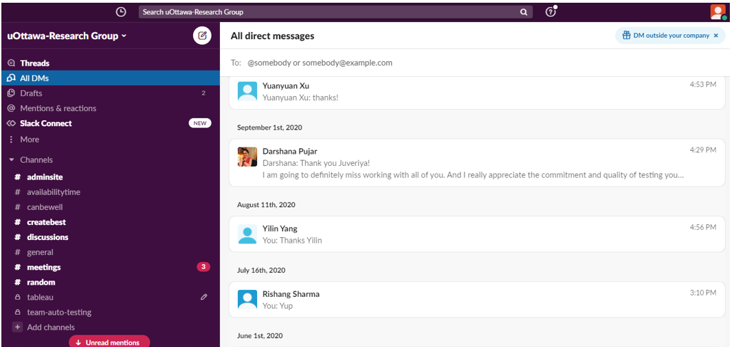
Figure 1. Automation testing channel on Slack

There is a separate channel in the Slack for testing.I was added to the auto testing team. Slack has three general groups: 1) CanBeWell, 2) Meetings and 3) Random

- CanBeWell group is used for making important announcements. I received notifications about testing task through this group only while performing manual testing CanBeWell.Once I find defect, I reported to the project manager for its validation on Slack only. Once it is verified and approved as a bug then we can process further.

- The CanBeWell group has 2 meetings per week, I usually have a Friday meeting where I reported the project manager on the task I will perform for the week regarding testing. What are the test case and scripts I am planning to work upon? Then, everyone ought to present the work or report it to Professor Peyton and he always improvised and guide us with innovative ideas to do well in the project.

- Random group is created for posting any general queries or assistance questions.For example, While I proposed the idea of automation testing,I asked for everyone’s opinion on the testing tool to be used for automating the test scripts.

Trello

“Trello is a collaboration tool that organizes your projects into boards. In one glance, Trello tells you what's being worked on, who's working on what, and where something is in a process[6]. In this project,the Trello board has proved to be immensely useful for tracking the progress of automation and manual testing work.
At first, the project manager defines the Trello Board name and create different columns such as“Things to do”, “In Progress”, “For Review”, “Approved”and, “Request for help”.To show the progress of my project, I have defined my task in the cards which is displayed by my name so that my manager and I will be on the same page regarding the project progress.After defining the tasks for the project, with every task completed it is moved to the next corresponding card.

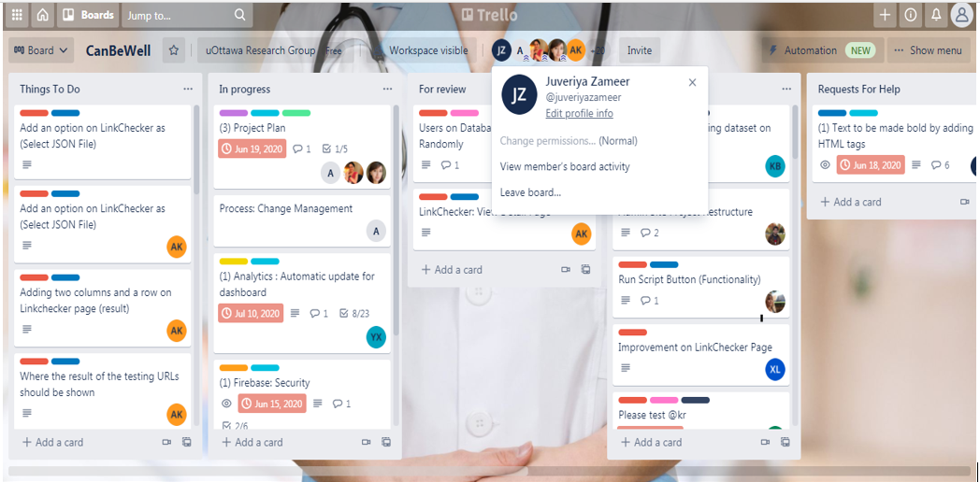
Figure 2 Trello board for Canbewell 1.0

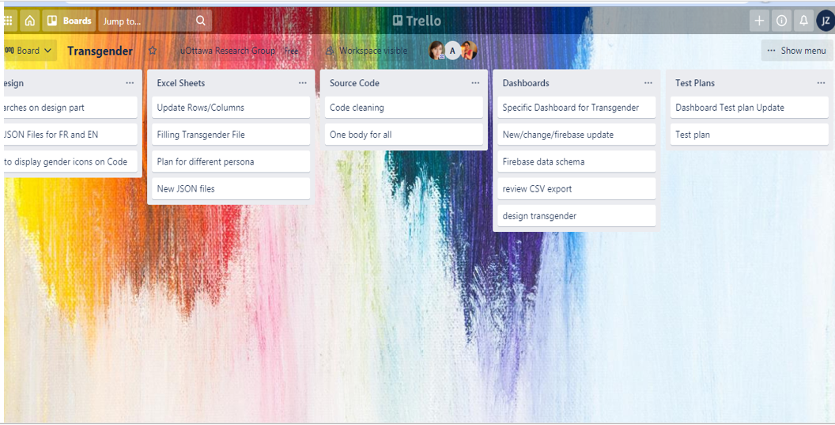
Figure 3. Trello board for Transgender/

Defined tasks on the Trello board for automation Project:

• Create a Test Plan with test cases and test steps for functionality testing in Excel.
• Test the web application manually and record bugs before automation testing
• Set up testing environment for Cypress.
• Writing test scripts for functionality testing.
• Executing the test scripts and record the process for future work.
In order to build a workflow in Trello, it is important to add information about the cards like, description, due date, member, checklists, attachments and comments. One can describe the title of the assigned task, add member to the cards, add checklists to the card that need sub task. date Importantly add a date to card is important to track deadlines,a notification will be received by a team member before it’s due.In this project I tend to set deadlines for each assigned task by the date menu, I can pick a start date and a due date to keep track of when projects and tasks begin and end. Once the tasks are completed, dates can be marked as done. One can also add attachments, cover etc. to design the Trello board.

GitHub

“GitHub is a Git repository hosting service, but it adds many of its own features. While Git is a command line tool, GitHub provides a Web-based graphical interface. It also provides access control and several collaboration features, such as a wikis and basic task management tools for every project”[7]. Some important features of GitHub are forking, pull request and merge,” The flagship functionality of GitHub is “forking” – copying a repository from one user’s account to another. This enables you to take a project that you don’t have write access to and modify it under your own account. If you make changes you’d like to share, you can send a notification called a “pull request” to the original owner. That user can then, with a click of a button, merge the changes found in your repo with the original repository.[7]

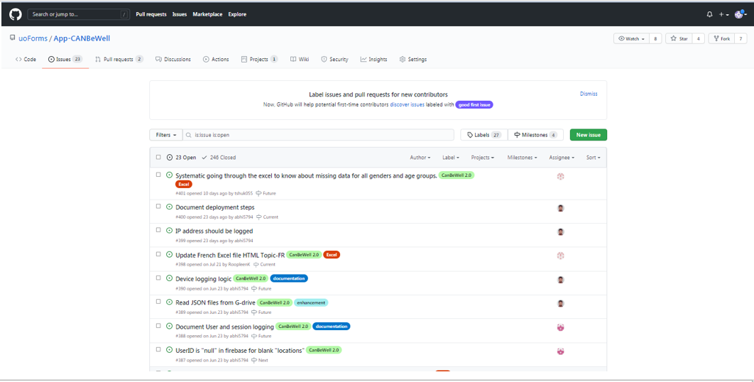
Figure 4. GitHub repository for Canbewell

I have used GitHub for logging defects once it is validated from the project manager. The bug is then assigned to the development team for fixing it. Once the bug is fixed, then regression testing is performed for each defect across multiple browser and devices. When I performed regression testing for the assigned defects, if it is fixed then I marked issue as resolved and add comment of my validation in the GitHub. In this project GitHub integrated with Visual studio code that allowed us to collaborate with others by sharing the testing script code through the GitHub pull request and Issues extensions.

Visual Studio

Visual Studio Code is a streamlined code editor with support for development operations like debugging, task running, and version control. It aims to provide just the tools a developer needs for a quick code-build-debug cycle [8]. In this project we have used visual studio with two tools

1) GitHub: GitHub integrates with Visual studio code that allowed us to collaborate with others by sharing the testing script code through the GitHub pull request and Issues extensions.

2) Cypress: Visual studio is also used as a code editor to write scripts and integrates it with Cypress to run test cases.

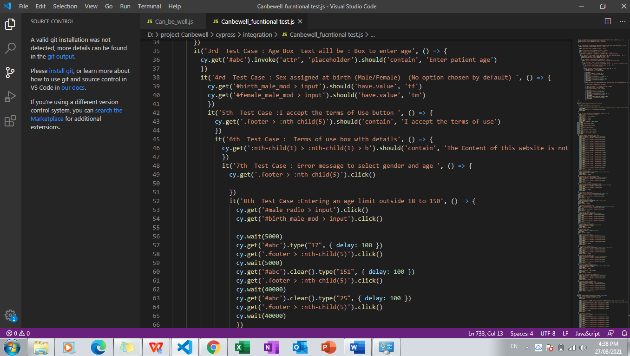
Figure 5. Visual studio code editor

Manual Testing: CanBeWell

Initially, in this project I have tested the CanBeWell site and transgender site across multiple browsers and devices. when the website only provides information regarding male and female with the bodies respectively, however; the web application becomes advanced as new features keeps adding to it. When features such as transgender body with information are added to the web application, it is modified into an advanced version of CanBeWell. Manual testing is a significant process for quality assurance due to the following reason:
- Human perspective is important as humans are the only ones who can look and evaluate the app's basic usefulness and appearance. Because the program is designed for humans alone, it can only perform a better job of validating from a user's perspective.
- Sometimes scenarios are un automatable, there are variety of cases that are either not worthy automating or do not provide strong confidence in user behavior when testing using automation.
- Cost of automation is another key factor here, sometimes, due to the timelines or size of the project, the extended efforts for the automation are not justifiable, and we always prefer a quick manual validation over the automation testing.

Creating Test Plan
In this project, the first step for testing the web application manually is by creating a test Plan. A Test plan worksheet comprises of three types of testing: functionality testing, content testing, URL testing and COVID testing. The plan starts with testing background information like, tester’s name, device, browser and important URLS.
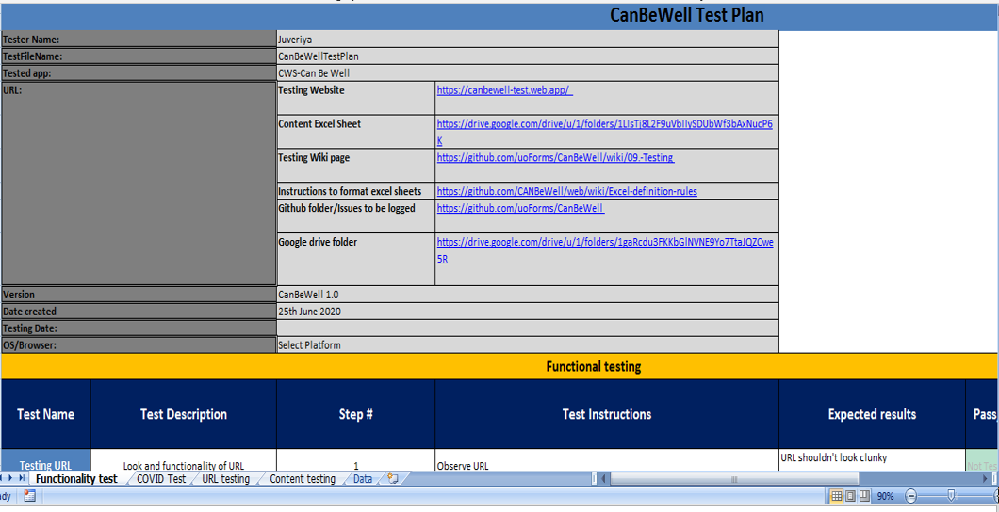
Figure 6. Canbewell 1.0 test plan
Functional testing: As it is seen in the figure above, the functional testing sheet has 6 columns: Test name, Test Description, Step#, Test Instruction, Expected results, and Pass.
- Test case: testing URL
Test steps: URL shouldn't look clunky
- Test case: testing entry page
Test steps:
- Entry page should have a huge logo of human body with Can Be well written on top of the logo
- "Mise a` jour" and "COVID Updated" should be written in French and English
- A yellow video button is placed next to "COVID Updated" and when clicked, opens a video related to CanBeWell app.
- A button for English language selection.
- A button for French language selection.
- "A reliable resource by Canadian health care providers to help you stay healthy" and "Rester en santé avec cette ressource créée par vos professionnels de la santé canadiens" should be written- both in english and french, below the logo.
- Test Case: Language Test
Test Steps:
- If English language is chosen, ALL the text in About page, Body, Topic and Test are in ENGLISH
- If French language is chosen, ALL the text in About page, Body, Topic and Test are in FRENCH
- Test Case: Test the About Page
Test Steps: for default state
- 1. Option to select User (Patient/provider)
- (Patient option chosen by default)
- 2. Option to select Gender (Male/Female)
- (No option chosen by default)
- 3. Box to enter age
- 4. Accept and Decline buttons
- 5. Terms of use box with details
Test Steps: On selecting Provider
- 1. Option to select Gender (Male/Female)
- 2. Box to enter age
- 3. All ages checkbox
- 4. Accept and Decline buttons
- 5. Terms of use box with details
Test Steps: Not entering a gender (Can be tested only in the default state)
- Error message to select gender and age between 18 and 150
Test Step: Clicking "Accept" Button
- Goes to body page (If other data is correct).
Test Step: Clicking "Decline" Button
- Goes to CanBeWell Entry page.

- Testing Main Page
Test Steps: On entering the main page, check the default functionality.
- 1.Three tabs on top - Body, Topics, Tests (Body tab selected by default)
- 2. A small box on left side to select user/age/gender
- 3. "Take the survey button" on right side
- 4. "Click any body part or icon" on the center
- 5. Various icons and body parts displayed in (and around ) the figure
- 6. Gender of the figure based on selection made in the about page

Test Steps: Click the information box of the top left.
- Following details should be displayed:
- Option to select -
- User (Patient/Provider)
- Gender (Male/Female)
- Age Box
- All Ages (Only for provider)

Test Steps: In Information box, enter age outside 18-150
- Error message to select gender and age between 18 and 150.

Test Steps: Place pointer on each icon.
- It expands a little.
Test Steps: Clicking any icon.
- A Grey window will open up, with blue bubbles showing headings/subjects.
- There are no typos, error in spaces, Caps and grammatical errors
- A arrow sign button is present on the start of the blue bubble, that expands the heading when clicked.
- The name of the icon is displayed on the left corner.
- The name of the icon should disappear after closing the blue window.
- The organ is highlighted and a gray window open up, with blue bubbles showing headings/subjects. There are no typos, error in spaces, Caps and spelling mistakes.
- The name of the organ appears on the left bottom corner.
- The name disappears after closing the window.

Test Steps: Click "Take the survey" button on the top right corner.
- Should be redirected to survey monkey link.

Test Steps: On entering the topics tab.
- Search window is present on top.

Test Steps: On clicking each topic.
- The details of the topic show up.

Test Steps: On entering the test tab.
- Search window is present on top.
- Search window is case insensitive (Typing text in small letter or caps does not affect the result)
- Topics are arranged alphabetically with the arrow sign at the beginning.

Test Steps: On clicking each test
- The details of the topic show up.
URL Testing: Here the task is to confirm the functionality of each URL present under the body, topic and test tab. The basis expectation is that each URL will redirect to the associated page if the link is functional.
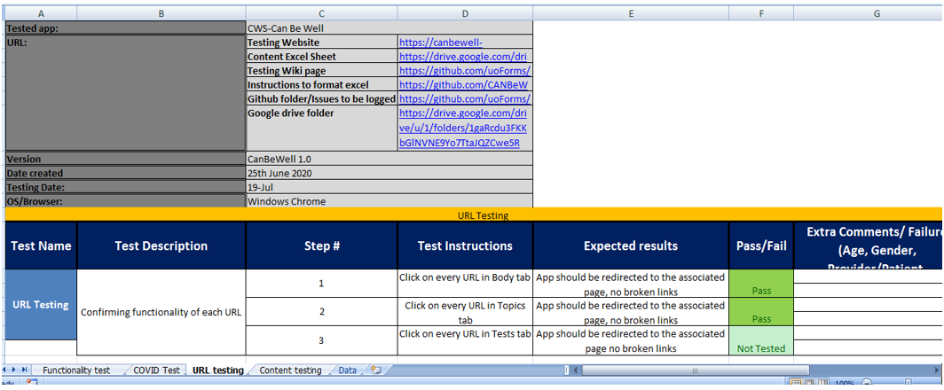
Figure 7. Canbewell Test Plan: URL testing
COVID Test: It is an additional requirement by Dr. Cleo to develop the web application with content COVID 19 focused. In the body web page, there is a big “COVID-19” icon which consists of valuable information regarding the virus. The aim of COVID test plan sheet is to ensure that all the content, links and functionality of elements are correct in this section. These are the new changes added to the test plan with their Test Results.
1 | "PRÉVENEZ LA COVID-19" changed to "COVID-19" in FR. | Pass
2 | The "COVID-19" topic both in EN, FR in the Top of the Topic List | Pass
3 | In COVID for EN and FR, extra spaces removed under each subject between lines and the after a bold subject section there is a space in the website | Pass
English Patient female 55
BODY , COVID-19:
First Nations , Métis, Inuit
4 | Video on physical distancing - No question mark at the end of the sentence  Before: Video on physical distancing? , After : Video on physical distancing | Pass
5 | Last item “See Ottawa Public Health …” change to "National links for First Nations, Métis and Inuit collected on the Ottawa Public Health Website” and this a link AND first item on list | Pass
6 | "Video on general COVID safety” put as 2nd item after “National information .." | Pass
7 | Video on physical distancing (Images/Inuktitut/English) 3rd item on the list | Pass
8 | Diabetes and COVID-19 4th item on the list | Pass
 | French Patient female 55
 | BODY, COVID-19
9 | Êtes vous inquiet d’avoir la COVID-19? , this link is used: https://ca.thrive.health/covid19/fr (note the /fr on the end ) | N/A
10 | COVID-19 Español …: Informations sur la COVID-19 dans différentes langues : new link - " Informations sur la COVID-19 dans différentes langues": https://www.santepubliqueottawa.ca/fr/public-health-topics/multilingual-resources.aspx .”Please make sure link is fully functional”. | N/A
11 | Différence entre la quarantaine et l’isolement. Cliquez sur ce lien (Adding ce) | N/A
12 | For FR, Tests, Row 2G, Avantages/inconvénients des tests, 2nd link, changed to this https://choisiravecsoin.org/lexamen-de-sante-annuel/ and 3rd link to https://choisiravecsoin.org/medecine-familiale/  Please make sure link is fully functional. | N/A
13 | For English part, Tests, Pros and cons of tests: for links : first one as is, then second one is https://choosingwiselycanada.org/health-check-ups/ and 3rd link is https://choosingwiselycanada.org/family-medicine/  Please make sure link is fully functional. | Pass
14 | For the French part, Femme, Age 20, Patient, Sujets:  Planification familial, new link : https://www.jogc.com/article/S1701-2163(16)39639-6/fulltext  Please make sure link is fully functional.  Check complete content and URL of row 63 : Ovary | N/A
15 | French, Topics, Row 24 D "Prevenir le cancer de la prostate" (repeated) removed from patient text  Check complete content and URL of row 24: Genitalia | N/A

Content Testing: In this project, it is important to ensure the correctness of the information provided to the user as it is a healthcare application, therefore; we must be careful while testing the content pop up in the dialog-box whenever a user clicks on the body icon or the organ. For this purpose, Dr. Cleo has provided a content sheet which has all the information she want to share with Canadian through CanBeWell. As a tester, my duty is to make sure that content present on the web application matches exactly with the content sheet in Excel.
Test Instructions | Expected results | Result
- Navigate to body tab of web app | The web app shows the exact same text as in the content sheet | Pass
- Parallely, open latest version of content excel sheet provided by the client from google drive(Link proivded on top) |  | Pass
- Every row in the excel sheet must be tested on the web app |  | Pass
- For instance:  Choose a row in the excel sheet, observe the inputs topic head, Gender, Min and Max age |  | Pass
- On CanBeWell website, select the same topic head, user (Say Patient), gender (say Female) and age (Say minimum age) as in the selected row in the content sheet |  | Pass
- Confirm if the web app displays the exact content as in he content sheet for |  | Pass
- Switch to different inputs as compared to step 5 (say make. Provider, max age) |  | Pass
- Repeat step 6 |  | Pass
- Repeat steps 4 to 6 for every permutation and combination in the content sheet |  | Pass
/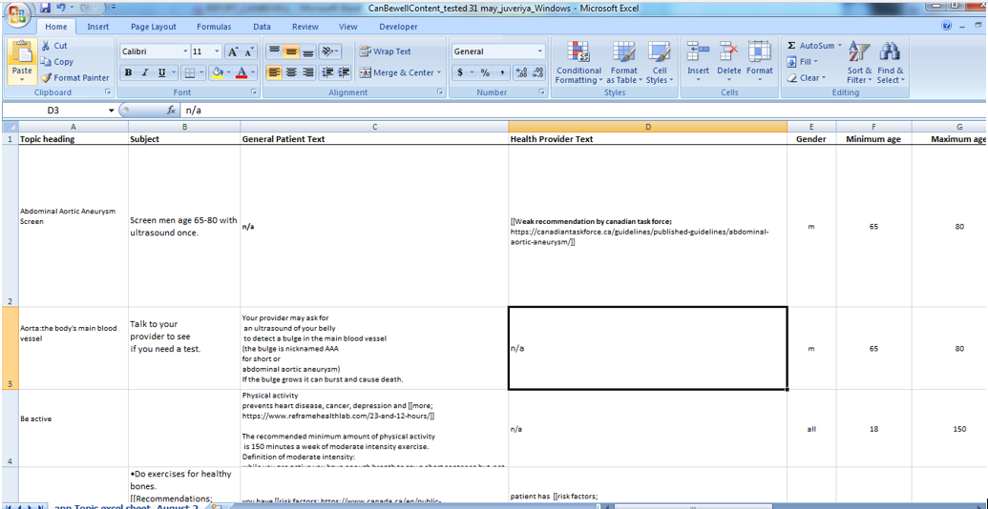
Figure 8. Content sheet for topic and Test tab in the application

Test Results by various Devices and Browsers

The testing had been done on various devices like, iPhone, Mac book, Windows and Android with browsers like, Chrome and Safari. The test results are reported in an excel file and uploaded on the google drive. The test results of the functionality, URL, content testing are as follows:

- CanBeWell Testing on iPhone: the issue is recorded and assigned as issue#136 on GitHub to me for validation once it gets fixed.

Functionality Testing

Test Step | Expected results |  | Comments/ Reason for failure
Place pointer on each icon | It expands a little | Fail | 1. Female Body/Male: On hovering to the icon it expands, however the shape pf the icon is changing from circle to semicircle.2. One exception to the genital part of female body is it multiplies into 2 genital icons when hover over it and the shape is circle for both the icons. 1. Male Body: Male genital part is not expanding at all.
Clicking any icon | A blue wondow open up, showing details | Fail | For physical activity in male no heading is available in the blue bubble. 2. For memory problems/dementia in male body, in the second blue bubble which says Testing available in certain situations, the plus sign is not aligned properly .3 No content is updated for Falls icon at the right thigh of female body
Click each organ | The organ is highlighted and a grey window appears with details about that organ | Fail | No content is available for Aorta.
Click each organ | The name disappears after closing the window | Fail | It appears on the bottom-left corner of the web page
Click on every URL in Body tab | App should be redirected to the associated page, no broken links | Fail | Issue# 202
Place pointer on each icon | It expands a little | Fail | female genital icon doubled itself into two
On entering Website. | "A reliable resource by Canadian family physicians to help you stay healthy" should be written- both in English and French, below the logo. | Fail | A green video button is present on the right side to Mise a` jour" and "COVID updated with white color text and box shadow style. 2) The size of blue buttons for English and French is may not the same, Size of button for francais is bigger than English. 3) A reliable resource by Canadian health care providers to help you stay healthy is the text written at the bottom of the page
On entering the test tab | Search window is present on top | Pass | Warning: there is a question mark on the top right after clicking on "Tests", and a help page pops up after clicking on the question mark.

CanBeWell Testing on Windows: the issues are recorded and assigned on GitHub to me for validation once it gets fixed.

Functionality testing on Windows: Functional testing is a technique by which QAs verify if a piece of software is behaving in accordance with pre-determined requirements is known as functional testing. It involves black-box testing methodologies, in which the tester is unaware of the internal logic of the system. Functional testing is solely concerned with ensuring that a system should functions as expected.
Place pointer on each icon | It expands a little | Fail | when hover the Icon with" sex and prostate" information, doesn't expand
Clicking any Icon | A blue window open up, showing details | Fail | Icon with a man doesn't have any information

Content Testing Results on Safari_iPhone: Content Testing, also known as Usability Testing, is the process to determine whether or not written content is relevant and appropriate for the intended audience, of whether or not they can understand and comprehend it. The main purpose of content testing is to validate User Experience, which signifies that the objective is not to see whether the reader ‘likes' the written content, but to check that it offers them with important and appropriate information that is written accurately.
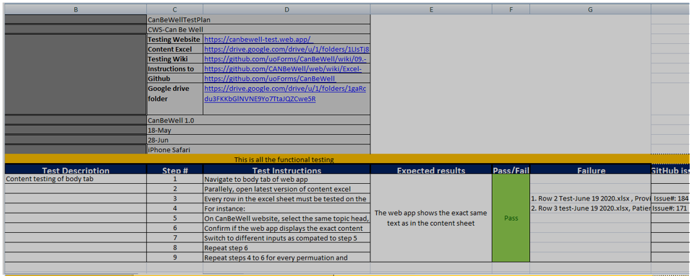
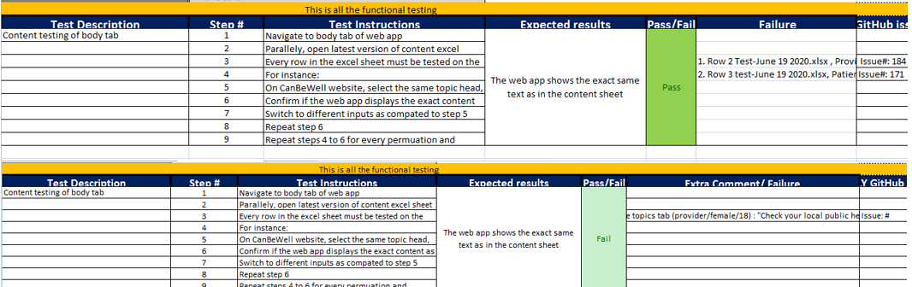

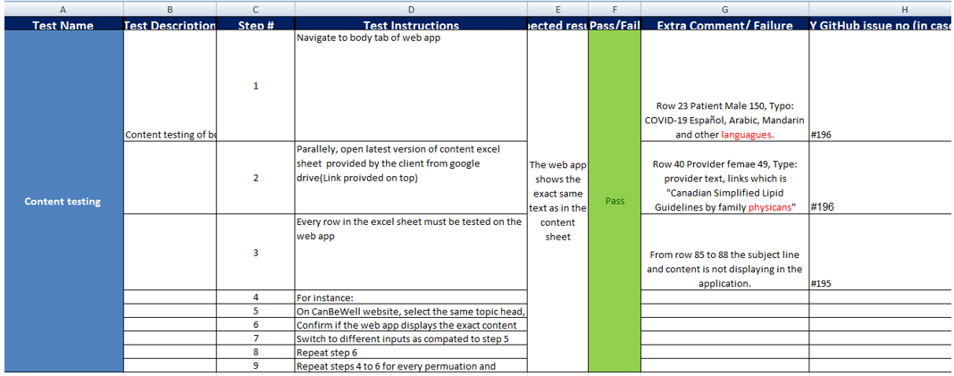
Figure 9. Content Testing in iPhone with Safari browser

URL testing: The purpose of URL testing is to check whether all the URLs present in the website are functional. As the project took some time to get fully developed there were links which got deprecated over time. Hence, while testing if the links comes out to be broken then the URL will be immediately fixed. If there is a change in the third party web page, the link becomes broken too. In such cases, the links are changed with alternative. Below is the list of broken website links that were changed to alternative links.
Broken URL | Alternative1
https://canadiantaskforce.ca/wp-content/uploads/2016/12/CTFPHC_Prostate-Cancer_HarmsBenefits_French_FINAL | https://canadiantaskforce.ca/wp-content/uploads/2016/12/CTFPHC_Prostate-Cancer_HarmsBenefits_French_FINAL.pdf
https://www.uspreventiveservicestaskforce.org/Page/Document/UpdateSummaryFinal/prostate-cancer-screening1?ds=1&s=prostate | https://www.uspreventiveservicestaskforce.org/uspstf/document/RecommendationStatementFinal/prostate-cancer-screening
https://www.uspreventiveservicestaskforce.org/Page/Document/UpdateSummaryFinal/folic-acid-for-the-prevention-of-neural-tube-defects-preventive-medication/ | https://www.uspreventiveservicestaskforce.org/uspstf/recommendation/folic-acid-for-the-prevention-of-neural-tube-defects-preventive-medication?ds=1&s=neural%20tube%20defects
https://thewellhealth.ca/wp-content/uploads/2016/12/Preconception-Tool_-Nov2015.pdf | https://cep.health/clinical-products/preconception/
https://www.uspreventiveservicestaskforce.org/Page/Document/UpdateSummaryFinal/prostate-cancer-screening1?ds=1&s=prostate | https://www.uspreventiveservicestaskforce.org/uspstf/document/RecommendationStatementFinal/prostate-cancer-screening
https://thewellhealth.ca/wp-content/uploads/2016/12/Preconception-Tool_-Nov2015.pdf | https://med-fom-obgyn.sites.olt.ubc.ca/files/2019/02/Preconception-Tool_-Nov2015-CEP_.pdf
https://www.uspreventiveservicestaskforce.org/uspstf/document/UpdateSummaryFinal/tobacco-use-in-adults-and-pregnant-women-counseling-and-interventions | https://www.uspreventiveservicestaskforce.org/uspstf/recommendation/tobacco-use-in-adults-and-pregnant-women-counseling-and-interventions
https://sogc.org/wp-content/uploads/2013/01/gui271CO1201E.pdf | https://www.jogc.com/article/S1701-2163(17)30936-2/fulltext
https://sogc.org/wp-content/uploads/2013/01/gui271CO1201E.pdf | https://www.jogc.com/article/S1701-2163(17)30936-2/fulltext
https://sogc.org/fr/ressources-et-publications/brochures-deducation-publique.html?id=1 | Needs report to Dr. Cleo

Log defects in GitHub

Once the issues are validated, these issues are logged in GitHub.

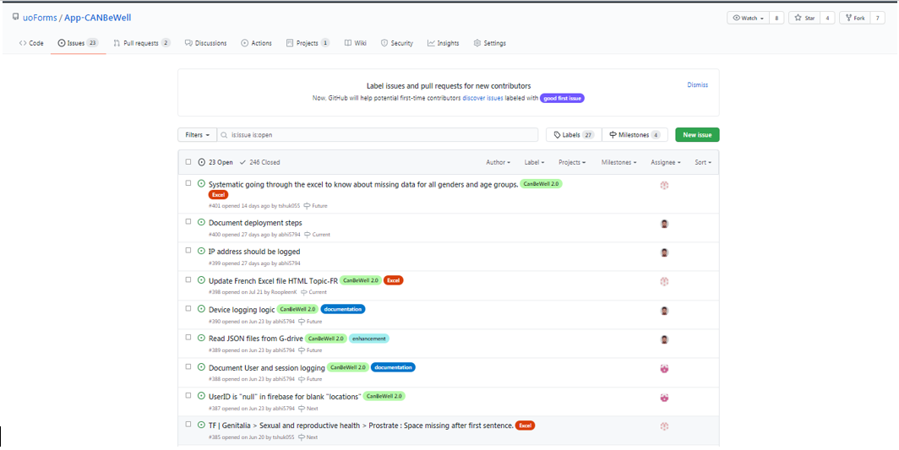
Figure 10. Logging Issues in Github

Regression Testing

Regression testing (rarely non-regression testing) is re-running functional and non-functional tests to ensure that previously developed and tested software still performs after a change. If not, that would be called a regression [11]. There are several rounds of testing every time a new change takes place. One such change proposed was regarding the Covid-19 icon in the body tab.

- COVID-19 Icon size : Size of the COVID icon is increased
- "Pros and Cons of tests" on top of the list in the test EN part
- Change of Updated research - In journals, "BMJ.." in COVID-19 provider - text after BMJ removed in EN and FR
- Body part- genital organ (M/F), displacement, uterus/ovary - fixed

- "Spaces in COVID part provider EN and FR
  - Spaces after each bullet in Vulnerable populations/Populations vulnérables
  - Spaces put before ""Journals"" and ""PUBLIC HEALTH AGENCY OF CANADA"""
- "In English/provider/Covid/Vulnerable populations the link ""Synopsis…"" is removed
- and instead, the below is put:

- First Nations, Métis and Inuit ( this would be a link to https://www.ottawapublichealth.ca/en/public-health-topics/resources-for-first-nations-inuit-and-m-tis-community-members.aspx)
- National and Ottawa-specific information

- Different languages ( this would be a link to https://www.ottawapublichealth.ca/en/public-health-topics/multilingual-resources.aspx)"
When changes are updated on the web application then it is tested on various devices across different browsers. The test results are as follows.
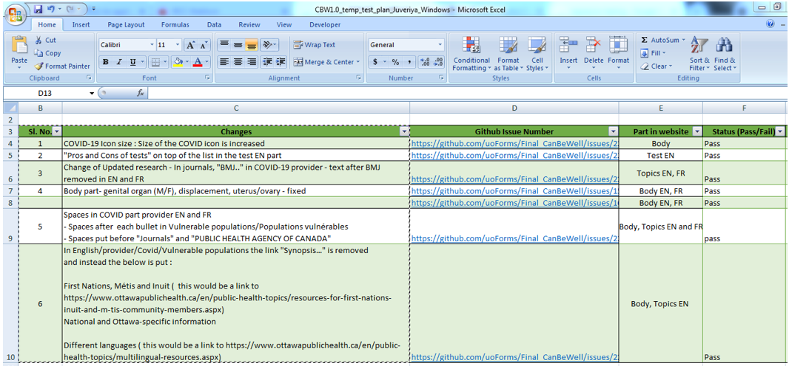
Figure 11. New Changes of covid 19 icon updated and tested

Automation Testing for CanBeWell 2.0

Creating Test Plan for Functionality testing

1. Test case: testing URL
Test steps: URL shouldn't look clunky

2. Test case: testing entry page
Test steps:
- Entry page should have a huge logo of human body with Can Be well written on top of the logo
- "Mise a` jour" and "COVID Updated" should be written in French and English
- A yellow video button is placed next to "COVID Updated" and when clicked, opens a video related to CanBeWell app.
- A button for English language selection.
- A button for French language selection.
- "A reliable resource by Canadian health care providers to help you stay healthy" and "Rester en santé avec cette ressource créée par vos professionnels de la santé canadiens" should be written- both in English and French, below the logo.

3. Test Case: Language Test
Test Steps:
- If English language is chosen, ALL the text in About page, Body, Topic and Test are in ENGLISH
- If French language is chosen, ALL the text in About page, Body, Topic and Test are in FRENCH

4. Test Case: Test the About Page
Test Steps: for default state
- 1. Option to select User (Patient/provider)
- (Patient option chosen by default)
- 2. Option to select Gender (Male/Female)
- (No option chosen by default)
- 3. Box to enter age
- 4. Accept and Decline buttons
- 5. Terms of use box with details

Test Steps: On selecting Provider
- 1. Option to select Gender (Male/Female)
- 2. Box to enter age
- 3. All ages checkbox
- 4. Accept and Decline buttons
- 5. Terms of use box with details.

Test Steps: Not entering a gender (Can be tested only in the default state)
- Error message to select gender and age between 18 and 150

Test Step: Clicking "Accept" Button
- Goes to body page (If other data is correct).

Test Step: Clicking "Decline" Button
- Goes to CanBeWell Entry page.

5. Test Case: Test the main Page (Gender combination testing)
Test Steps: Gender, Male Sex Assigned at Birth: Male
- Male Body and Information inside the Body, Topics, Test tab must show up.

Test Step: Gender, Female Sex Assigned at Birth: Male
- Transgender Body and Information inside the Body, Topics, and Test tab must show up.

Test Step: Gender, Female Sex Assigned at Birth: Female.
- Female Body and Information inside the Body, Topics, and Test tab must show up.

Test Step: Gender, Female Sex Assigned at Birth: Male.
- Transgender Body and Information inside the Body, Topics, and Test tab must show up.

Test Step: Gender, Non Binary Sex Assigned at Birth: Male, Female.
- Transgender Body and Information inside the Body, Topics,Test tab must show up.

- Testing Main Page
Test Steps: On entering the main page, check the default functionality.
- 1.Three tabs on top - Body, Topics, Tests (Body tab selected by default)
- 2. A small box on left side to select user/age/gender
- 3. "Take the survey button" on right side
- 4. "Click any body part or icon" on the center
- 5. Various icons and body parts displayed in (and around ) the figure
- 6. Gender of the figure based on selection made in the about page

Test Steps: Click the information box of the top left.
- Following details should be displayed:
- Option to select -
- User (Patient/Provider)
- Gender(Male/Female)
- Age Box
- All Ages (Only for provider)

Test Steps: In Information box, enter age outside 18-150
- Error message to select gender and age between 18 and 150.

Test Steps: Place pointer on each icon.
- It expands a little.
Test Steps: Clicking any icon.
- A grey window will open up, with blue bubbles showing headings/subjects.
- There are no typos, error in spaces, Caps and grammatical errors
- A arrow sign button is present on the start of the blue bubble, that expands the heading when clicked.
- The name of the icon is displayed on the left corner.
- The name of the icon should disappear after closing the blue window.
- The organ is highlighted and a gray window open up, with blue bubbles showing headings/subjects. There are no typos, error in spaces, Caps and spelling mistakes.
- The name of the organ appears on the left bottom corner.
- The name disappears after closing the window.

Test Steps: Click "Take the survey" button on the top right corner.
- Should be redirected to survey monkey link.

Test Steps: On entering the topics tab.
- Search window is present on top.

Test Steps: On clicking each topic (The Content for Transgender/(Male/Female)must differ)
- The details of the topic show up.
- Search window is case insensitive.
- Topics are arranged alphabetically with the arrow sign at the beginning , except COVID-19 which is at the top of the list

Test Steps: On entering the test tab.
- Search window is present on top.
- Search window is case insensitive (Typing text in small letter or caps does not affect the result)
- Topics are arranged alphabetically with the arrow sign at the beginning.

Test Steps: On clicking each test
- The details of the topic show up.

Set-up automation testing environment: Installing Cypress
To install Cypress via npm, yarn, via direct download, version and run Cypress via package.json.
System requirements
To use Cypress, you will have to install the desktop application on your computer.
- Windows 7 and above
If you are using npm to install Cypress, Cypress supports
- Node.js 8 and above
Installing options: Option A
1. Installing via npm
- You can install Cypress via npm, to do this you have to cd into your project directory and run
- npminstall cypress -save-dev
- when you run this, it will install Cypress as a dev dependency for your project.
- Ensure that you either have a package.jsonfile or a node_modulesfolder in your project directory. This ensures that Cypress is installed in the correct directory.
The Cypress documents recommend that you install Cypress with npm because:
- Cypress is versioned just like any other dependency.
- Using npm simplified the process of running Cypress in continuous Integration.
2. Installing via yarn
- You can also install Cypress using yarn, to do this, you have to cd into your project directory, then you run the command shown below:
- Yarn add cypress --dev
Option B: Direct download
Option A of this guide is only applicable if you are using Node or npm in the project, if you are not, you can always download the zipped file to try Cypress out (https://download.cypress.io/desktop). However, you will not be able to record the Dashboard, this file is only useful when you want to try Cypress out.
The direct download always uses the latest available version and it will detect your platform automatically. Once you download the zipped file the first step is to unzip, then double click on it. Cypress runs without having to install any dependencies.
Opening Cypress
If you installed Cypress using npm, Cypress is installed to your ./node_modulesdirectory, and the binary executable is accessible from ./node_modules/.bin.
You can now open Cypress from your project root in either of the following ways:
- By going through the long way using the full path, that is by running the following command from your terminal ./node_modules/.bin/cypress open
- With the aid of a shortcut using npm bin. This is done by running $(npm bin)/cypress open
- With the use of npx, to do this you have to run npx cypress open.
- Finally, you can open Cypress using yarn by running yarn run cypress open
Switching browsers
The Cypress Test Runner will attempt to find all the compatible browsers on your machine. You will find the drop down to select a different browser is in the top right corner of the Test Runner.
/
Adding npm scripts
Although there is nothing wrong with writing out the full path to the Cypress executable each time, it is much easier and clearer for you to add Cypress commands to the scripts field of your package.jsonfile.
{"scripts":{"cypress:open":"cypress open"}}

Once this is done, you can open cypress from your project by running the following command:
npm run cypress:open
CLI tools
When you install Cypress using npmyou also get access to many other CLI commands.
As of Cypress version 0.20.0, there is a node_modulethat you can require in your Node scripts.
Advanced
Environment variables
CYPRESS_INSTALL_BINARY, CYPRESS_DOWNLOAD_MIRROR, CYPRESS_CACHE_FOLDER,
CYPRESS_RUN_BINARY, CYPRESS_SKIP_BINARY_INSTALL, CYPRESS_BINARY_VERSION
Install binary
You can use the CYPRESS_INSTALL_BINARY environment variable to control how Cypress is installed. If you want to override what is installed, you have to set CPRESS_INSTALL_BINARY alongside the npm install command.
This is helpful when you want to:
- Install a version of Cypress that is different from the default npm package.
'''CYPRESS_INSTALL_BINARY=2.0.1 npminstall cypress@2.0.3'''
- Specify an external URL (in order to bypass a corporate firewall)
'''CYPRESS_INSTALL_BINARY=https://company.domain.com/cypress.zip npminstall cypress'''
- Specify a file that you want to install locally, rather than using the internet.
'''CYPRESS_INSTALL_BINARY=/local/path/to/cypress.zip npminstall cypress'''
Skipping Installation
You can force Cypress to skip the installation of the binary application, all you need to do is to set CYPRESS_INSTALL_BINARY=0.
CYPRESS_INSTALL_BINARY=0npminstall
When you run the above command from the command line, Cypress skips its install phase once the npm module is installed.
Download URLs
To download a particular version for a given platform (operating system), you can get it from the CND. The base download server URL is https://download.cypress.io
Here is a list of the available URLs:
- Windows 64-bit (?platform=win32&arch=x64)
Mirroring
You can specify CYPRESS_DOWNLOAD_MIRROR if you choose to mirror the entire Cypress download site, this will set the download server URL form https://download.cypress.io to your own mirror.
Here is an example:
'''CYPRESS_DOWNLOAD_MIRROR="https://www.example.com" cypress install'''
Option C: I used this option for my project, following are the steps:
- Download first Node JS from “https://nodejs.org/en/”
- after download and install node JS then create a folder for cypress in your document and open a folder/
- Open command prompt, by right click in the cypress folder or click on file on from top menu and open cmd (command prompt)
- Type "npminit" so this will install the package for you.
- One may type npm install cypress or npm install cypress --save-dev // Make sure that you have already run npminit and the cypress installation process will be started.
- After cypress installation, go the cypress folder and you will see the integration folder in it.
- Paste the can_be_well.js file in the integration folder.
- //Open Cypress
- node_modules/.bin/cypress open or add "cypress": "cypress open" in your package.json then npm run cypress
- Locate the folder integration and run can_be_Well.js file.

Test Scripts Code

The test script code “can_be_well.js” is uploaded on GitHub. It can be downloaded from there for future use.

GitHub Code Link

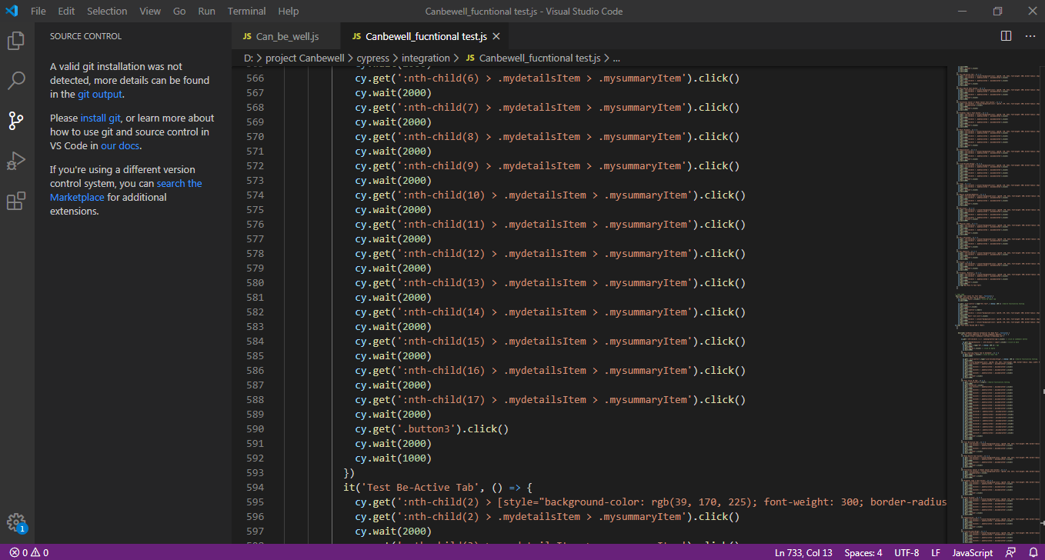
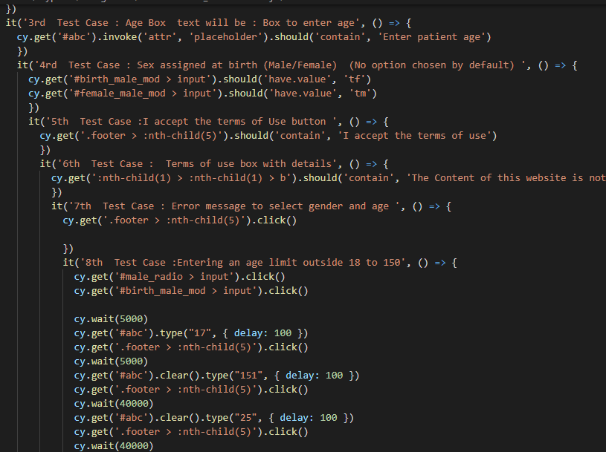
Figure 12. Code snippets from can_be_well.js file in Visual studio code editor

Test Results

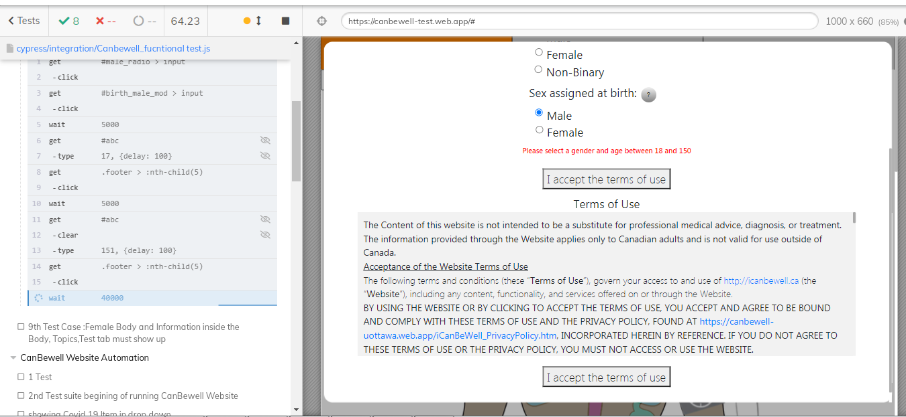
Figure 13. Executing test script in Cypress Test Runner
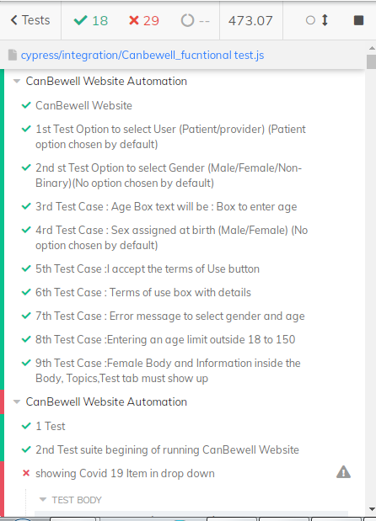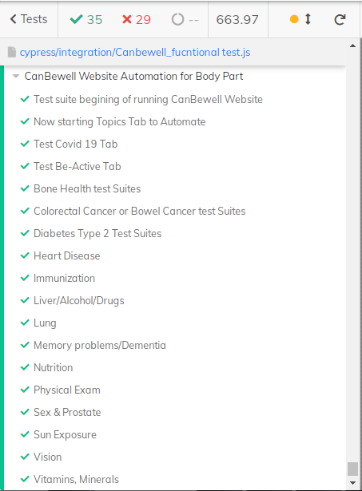

Figure 14. Test Results in test runner

Comparative study on Cypress and Selenium as Functional testing tool:

In this project, automation testing has become a requirement as Canbewell was a complex project which needs to be tested in a shorter testing time. Currently, most of the companies use Selenium extensively to verify their web application’s functionalities as it supports multiple web browsers and programming languages. However; there are some limitations based on my project requirement which makes Cypress as my first choice over Selenium. In this section, we will compare parameters like cost, GUI testing, test coverage, ease of use and effectiveness of Test script writing and executing in Selenium and Cypress.

Test Efficiency

It is observed that Selenium takes most of its execution time in instantiating the WebDriver and initializing the application. Browser initialization is responsible for slowing down the test execution time as execution test case in Selenium is faster but the complete regression suite execution time gets delay due to browser initialization.
In terms of test efficiency, there is a significant difference between Selenium and Cypress. Cypress generates fewer lines of code than Selenium. This indicates that writing automation scripts in Cypress requires less effort, which significantly increases its test efficiency when compared to Selenium. Most Selenium codes must be instantiated with libraries and import pages, whereas Cypress caters to the majority of the automation script directly.
“Cypress provides a better test efficiency compared to Selenium as Cypress takes shorter lines of code needs to write in order to complete a test scenario. Moreover, it will indirectly improve the efficiency of the effort in writing the test automation scripts”.[9]

Requirement-based test coverage

The test cases in Selenium and Cypress completely cover all of the requirements. This indicates that the automation scripts written in both tools are capable of carrying out the designed test cases.

Graphical user interface testing

Cypress includes an interactive dash-board dubbed "Test runner" that was extremely beneficial for visualizing the tests as they progressed. The testing efficiency was 75% since it fluctuated according to the processor speed. The test cases were able to uncover intended problems prior to the application's release. Cypress testing was simple and well-guided. It was simple to implement the test cases using Cypress's various built-in commands. Additionally, the ability to create custom commands simplified execution.

Cost

Cypress scripts can assist in implementing shift left tests. Shift left occurs in the majority of testing projects but cannot be completely executed due to a lack of tools and understanding about the benefits of testing early in the life cycle. Shift left is a critical testing method that enables testing teams to spend less time identifying flaws and more time building practices to prevent them.Cypress scripts enable front-end developers and quality engineers to collaborate on the early detection of faults in web components. Cypress Test Driven Development (TDD) scripts let these components to be tested soon after they are produced. As a result, faults can be addressed immediately during the development stage. Testing teams do not need to be concerned about discovering these same issues during a subsequent development stage, as Cypress tests continue to verify components over subsequent stages. Cypress has significantly reduced the cost of defect repair as compared to alternative tools.

Ease of Use

Setup is simple. No dependencies or additional downloads required on the other hand, Setup is a bit challenging as it requires downloading browser-specific drivers and setting up the test environment [12].

Conclusion:

To summarize, the project briefly describes the process of manual and automation testing. Automation tool named Cypress is used to run the test scripts for functional testing of Canbewell 2.0. Cypress is used due to the fact that Cypress provides a better test efficiency compared to Selenium as Cypress takes shorter lines of code needs to write in order to complete a test scenario. Moreover, it will indirectly improve the efficiency of the effort in writing the test automation scripts. In addition to it, it is cost effective, easy to use and appropriate for graphical user testing.

Future work:

The project covers the functional testing of Canbewell 2.0. The Cypress tool can also be used for Usability testing or unit testing as the project progress further.

References
[1] A. S. M. Mosa, I. Yoo, and L. Sheets, “A Systematic Review of Healthcare Applications for Smartphones,” BMC Med. Informatics Decis. Mak. 2012 121, vol. 12, no. 1, pp. 1–31, Jul. 2012, doi: 10.1186/1472-6947-12-67.
[2] Nazli, F. Fatehi, M. Fallah, D. Walters, and M. Karunanithi, “Self-Management Education Through mHealth: Review of Strategies and Structures,” JMIR Mhealth Uhealth 2018;6(10)e10771 https//mhealth.jmir.org/2018/10/e10771, vol. 6, no. 10, p. e10771, Oct. 2018, doi: 10.2196/10771.
[3] “Software Engineering | Software Quality Assurance - javatpoint.” [Online]. Available: https://www.javatpoint.com/software-quality-assurance. [Accessed: 27-Aug-2021].
[4] “Why Cypress? | Cypress Documentation.” [Online]. Available: https://docs.cypress.io/guides/overview/why-cypress. [Accessed: 27-Aug-2021].
[5] “Tools QA - Cypress Tutorial for Beginners: Getting started with End to End Testing.” [Online]. Available: https://www.toolsqa.com/cypress-tutorial/. [Accessed: 27-Aug-2021].
[6] “What is Trello? - Trello Help.” [Online]. Available: https://help.trello.com/article/708-what-is-trello. [Accessed: 27-Aug-2021].
[7] “What Exactly Is GitHub Anyway? | TechCrunch.” [Online]. Available: https://techcrunch.com/2012/07/14/what-exactly-is-github-anyway/. [Accessed: 27-Aug-2021].
[8] “Visual Studio Code Frequently Asked Questions.” [Online]. Available: https://code.visualstudio.com/docs/supporting/FAQ. [Accessed: 27-Aug-2021].
[9] F. Mobaraya and S. Ali, “TECHNICAL ANALYSIS OF SELENIUM AND CYPRESS AS FUNCTIONAL AUTOMATION FRAMEWORK FOR MODERN WEB APPLICATION TESTING,” pp. 27–46, 2019, doi: 10.5121/csit.2019.91803.
[10] A. Asadzadeh and L. R. Kalankesh, “A scope of mobile health solutions in COVID-19 pandemics,” Informatics Med. Unlocked, vol. 23, p. 100558, Jan. 2021, doi: 10.1016/J.IMU.2021.100558.
[11] “What is Slack? | Slack.” [Online]. Available: https://slack.com/intl/en-in/help/articles/115004071768-What-is-Slack-. [Accessed: 29-Aug-2021].
[12] “Cypress vs Selenium: Key Differences | BrowserStack.” [Online]. Available: https://www.browserstack.com/guide/cypress-vs-selenium. [Accessed: 29-Aug-2021].

